Our Guest Speaker, following the Society’s Annual General Meeting at the RAF Club on 8 September 2021, was
Chris Pocock
whose topic was
THE RAF AND THE U-2 –
PROJECT OLDSTER FROM THE INSIDE
Following my previous article for Journal 77, tonight I am going to provide some personal perspectives from the RAF pilots who joined the US U-2 project to overfly the Soviet Union in the mid to late 1950s. These perspectives come from selected AIR40 class files, now declassified and available for inspection at The National Archives, plus some autobiographies and interviews.
First, though, a short introduction to the unique aircraft that was developed under CIA sponsorship as Project AQUATONE, and built by the Lockheed Skunk Works. The go-ahead was given in November 1954. A new airfield was constructed in the Nevada desert so that test flights could be conducted in total secrecy. The first flight was in August of 1955 and CIA pilot training began in January 1956. The US Air Force airfield at Lakenheath was chosen for the first overseas detachment, however the British government withdrew permission after the Buster Crabbe incident. But Germany granted permission, and the first overflights of the Soviet Union were staged from Giebelstadt in June 1956.
The vital statistics of the early U-2s were:
Length 50ft; Wingspan 80ft
Aspect ratio 11:1
Maximum take off gross weight 19,665lb
P&W J57-11,200lb st
Range 4,175nm on 1,335gal
10 hours @ max alt 72,500ft
B-camera, focal length 36in
ELINT + COMINT
Dedicated SIGINT
Over the next two years, there were 19 overflights. But, contrary to expectations, some of them were detected by Soviet radars, although the MiGs could not reach the U-2’s cruising altitude. President Eisenhower took heed of Soviet diplomatic protests, and became increasingly reluctant to sanction more overflights. However, US intelligence detected a gap in Soviet early warning radars along the southern border in Tajikistan and Kyrgistan. The second CIA detachment was at Incirlik, in Turkey, with more successful overflights being made via deployments from there to Peshawar in Pakistan.
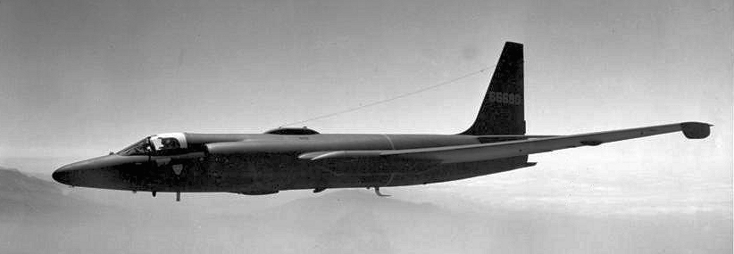
The US Air Force provided vital support to the CIA detachments, and bought its own fleet of U-2s. It established a training squadron at the remote Texas base of Laughlin, where pilot training began in November 1956. The Air Force then flew high-altitude air sampling missions over friendly airspace, monitoring worldwide stratospheric fallout from Soviet nuclear tests but also collecting debris for weapons diagnostics purposes.
A classic early U-2 without the slipper tanks.
The US invited the UK to join the CIA project after its Director, Richard Bissell, suggested that ‘British’ overflights might be approved by the British Prime Minister, rather than the US President. Of course, Eisenhower had to agree to this scheme. Some complicated negotiations followed about the practicalities.
Four RAF pilots, Sqn Ldr Chris Walker, Flt Lt Mike Bradley, Flt Lt David Dowling and Flt Lt John MacArthur, were recruited, all of them A2 flying instructors with jet experience. They were sent for training at Laughlin in March 1958. British participation in the programme was codenamed Project OLDSTER and the RAF established a small, and top secret, organization to manage its involvement. Initially headed by AVM Ronnie Lees, ACAS (Ops), who was succeeded by AVM Sir John Grandy in October 1958, other early key players included AVM Sid Bufton, ACAS (Int) and, as DD Ops (Recce), Gp Capt Stuart Wise, Gp Capt Thomas Bingham-Hall and Wg Cdr Colin Kunkler; Wg Cdr Norman Mackie was attached to CIA Project HQ.
David Dowling, who was serving as an instructor pilot on Canberras, recalled:
‘In March 1958 I took some leave and was at home in Wales when I was called to the telephone, it was the Adjutant at Bassingbourn. He asked if I could make the Air Ministry at eleven the next morning for an interview with the Assistant Chief of Air Staff (Operations), Air Vice Marshal Lees. I looked at my watch; it was already past mid-day, if I left by road, I could make it. I said, “Yes”, but what was it all about? He had no idea but said “be there”. I packed my bag and said goodbye to my parents and left for London, I stayed the night at the RAF Club. The next morning, I reported to the office of ACAS Ops. There were two other officers waiting, one I knew, Flt Lt John MacArthur who had been on my entry at Cranwell. The other, Flt Lt Mike Bradley, I did not know. None of us knew why we had been called, nor did the office staff know. We went in for interview one at a time. I was last. The other two when they came out looked rather sheepish and said they would wait for me. I went in and was told to sit down. I was asked some general questions about my life interests. Was I courting any girl seriously to which I said, “No.” He then told me I was to go to the United States for two weeks or perhaps longer. I would have to have a medical that afternoon in London. If I passed that, I would be given more instructions when I was in the States. If I had any reason why I did not wish to go I should say so now. I had none; the interview was over.’
According to Mike Bradley, the CIA requested that four British pilots be sent for training, because they expected only two to pass the medicals. These were rigorous, especially at the renowned Lovelace Clinic in New Mexico. David Dowling recalled:
‘It was horrific; we were each given a card with our schedule for the week. We had tubes pushed down our throats and up our backsides, samples taken, stuff injected and had to drink and eat many different kinds of liquid and food. We were X-rayed in every position and had brain scans. Doctors and psychologists interviewed us. At night we had to take back to our motel whole batches of enemas and test medication to take for the next day’s sessions. We had books of questions to answer for the psychologist. We had not come across this breed of doctor before and found, to our minds, some of the questions insulting and perverse.’
The four pilots also took an escape and evasion course at the CIA’s Camp Peary in Virginia. David Dowling again:
‘We were given general survival training on how to live off the land; we caught or shot our food, learnt to prepare and cook the catch. We did firearms training… Much of our training was centred on escape. We were taught the art of lock-picking and were shown several pieces of equipment that James Bond might use… Perhaps the highlight was how to cross defended borders, such as that between the Soviet Union and Western Europe with its minefields and complicated fencing with watch towers and booby traps.’
Then it was off to Laughlin for the pilot training course. The RAF trainees had still not been told what aircraft they were to fly. They arrived at the remote Texas base in the evening, and were introduced to their instructor pilots. John MacArthur recalled the meeting at the 50th Anniversary reunion of the Dragon Lady Association in 2010, perhaps slightly embellishing the story to amuse his audience of U-2 veterans:
‘Tony and Pat said to us, “What’s been your average mission time?” I said, “In the Meteor about 45 minutes, and in the Hunter 55 minutes.” And they fell about laughing. Drawing myself to my full 5ft 9in, I haughtily asked, “What’s wrong with that?” Then they asked, “What’s been your longest mission?” I remembered ferrying an airplane from the UK to Germany, so I told them one hour and a half. And they all fell about laughing again. They said, “How does nine hours grab you?” I said, “Nine hours? On my own?” “Yes.” “And I can’t scratch my nose?!” I thought, this had better be a hot ship! Next morning, on the ramp, there she was. We looked at this thing. I remember saying, “Is that it? You mean nine hours in that?” “Yes”, they said, “Nine hours – in that!”’
The ground school especially included polar and astro navigation, since the U-2’s ‘navaids’ were limited to an ADF, visual reference to the ground through a drift sight with magnification or, if cloudy, time and distance. More about this later. There was no U-2 dual trainer, so the pilots’ first flight would be his first solo. David Dowling recalled:
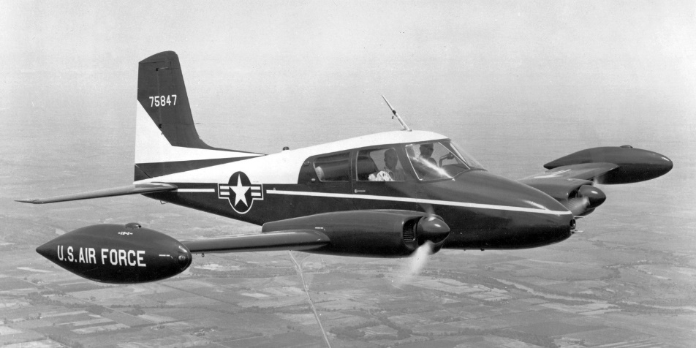
‘Because the U-2 had some peculiar and dangerous handling characteristics, our instructor would take us up in a Cessna 310 light piston twin aircraft and demonstrate a simulated U-2 circuit pattern. The U-2 had very good gliding characteristics and with the engine at idle it would glide for miles. The main difficulty was to position the aircraft on the approach path low enough and at exactly the right speed for a touchdown in the first third of the runway. This sounds easy, but for the first time you did not quite know what to expect and it was sweat making. It would float and, if touched down too early, would bounce and leave you on the stall with no power available some feet off the ground. You could not accelerate the engine from idle quickly; it would cough and cough as it gulped for more air, the whole airframe would shudder. The engine would slowly accelerate through the first 40 per cent of power and then come on full power with a mighty rush. If you bounced, the likelihood was that you would stall and crash. I did three flights in the Cessna to simulate the U-2 approach and landing. We used a quarter flap down and about 40 per cent power so that a very flat approach and landing was made. With these con-ditions set the Cessna would float for a long way as you eased it onto the runway. I had three further flights in a T-33 before my first flight in the 'U-Bird' on the 4th of June 1958.’
The Cessna L-27 (later U-3) was used to introduce pilots to the unique landing technique demanded by the U-2. (AirHistory.net).
Flying to altitude posed another set of challenges, as can be seen from the graph at Figure 1, which illustrates the very narrow margin between stall and Mach buffet at high altitude. David Dowling said:
Fig 1. Extract from the C-model flight manual.
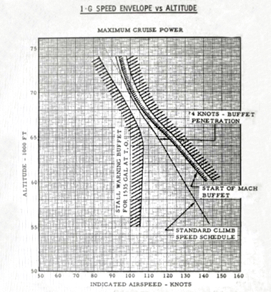
‘You flew on autopilot and every few thousand feet you had to adjust speed to a strict schedule and keep within a knot or two. If you were the least bit inattentive the autopilot would wander or go out of trim, both conditions being dangerous as you only had ten knots in balanced flight between the high and low speed stall. A two knot divergence from plan and you were within three knots of the limit…
To stay alive, you had to watch the airspeed needle like a hawk… The major problem was that the autopilot was never designed for these altitudes or fine limits. It was frightening at times as you looked back at the instruments after looking through the scope and see that the airspeed had gone up two or three knots and was accelerating. You watched the needle for a second or two to see if the autopilot was reacting, if not you had to manually re-trim the autopilot or disconnect and reset. One problem you could encounter was when the autopilot trim had not adjusted the aircraft trim and was holding the elevator force. If you released under these conditions the elevator would snap up or down and cause an upset, putting you out of control.
Turns at altitude were another delicate manoeuvre. If you used more than fifteen degrees of bank, the aircraft might tend to sink slightly with the nose going up or down, but once again you had to hold the speed exactly as any change was dangerous. There were three additional factors to take into account in the turn, the stalling speed increases, drag increases and the inside wing is moving slower.’
On the afternoon of 8 July 1958, Chris Walker was killed when his aircraft went out of control at high altitude and crashed in the Texas panhandle near Amarillo. He was found dead on the ground, still in his ejection seat. The next morning, a US Air Force trainee pilot, Capt Al Chapin, crashed in similar circumstances less than 100 miles away. The USAF grounded all its U-2s while accident investigations were carried out. Walker’s autopsy revealed that he had become hypoxic; it was soon suggested that both accidents could have been the result of the pilots being starved of oxygen, after the supply was restricted by ice formation at the reducer valve. There was evidence of a fire in Chapin’s oxygen supply.
On 25 July, a U-2 caught fire on the ramp at Laughlin while a ‘Tech Rep’ was checking a new oxygen pressure reducing valve. On 2 August, while investigations continued, the U-2s were cleared to fly again, but only as high as 20,000 feet. Four days later, another USAF pilot was killed on his first U-2 flight when the aircraft stalled on final approach, rolled rapidly to the left and struck the ground in a near-vertical attitude.
The USAF insisted that the ejection seats be disabled until Lockheed could assure their reliability. As another precaution, the radio leads to the pilot’s helmet were re-routed so that they no longer ran alongside the oxygen tubes: a short-circuit in that wiring could have caused a fire in the cockpit.
Chris Walker was buried in a cemetery at Montgomery, AL, alongside 78 RAF airmen who had been killed during flying training in the Second World War
The US had been sharing much of the imagery from U-2 flights with the UK. The arrangement was working well, so Wg Cdr Bob Abbott, a senior photo-interpreter at JARIC was sent to the CIA’s Photographic Interpretation Center in Washington, codenamed AUTOMAT.
Training completed, the three surviving pilots returned to the UK. They still did not know their final destination until they were briefed by Wg Cdr Kunkler in London. Here they were joined by a flight surgeon, Flt Lt John Clifford. The briefing included their cover story. They were to pretend to be civilian meteorological officers, deployed to help organize weather reconnaissance flights by the U-2. MacArthur thought it was a very thin veneer.
They flew on to Turkey in mid-November, and were soon joined by a British mission planner, Flt Lt Mike Collingwood. At Incirlik, they found Detachment B to be a slick operation of some 50 people, led by a USAF colonel, with a CIA officer as his executive. The CIA also provided the communications and security personnel. Other USAF officers and airmen performed operations and logistics functions along with ‘Tech Reps’ from Lockheed and contractors for the sensors, pressure suits and so on. There were seven American pilots, all former USAF officers who had signed contracts to join the CIA, with a promise that they could subsequently return to the service.
Those pilots were paid more than three times that of their equivalents in the USAF. There was a debate in London on whether the RAF pilots should be similarly recompensed. In the event, they were, and this was out of MI6 funds, according to Robbie Robinson, who was selected as Walker’s replacement. ‘As a lowly squadron leader, I was paid more than the Chief of the Air Staff!’ he said.
The first of three deployments from Incirlik to Watton were made in December 1958. Genuine weather package flights were flown from there, to support the cover story. The deployment also served as a test of the ‘Fast Move’ procedure that had been devised to make U-2 deployments as covert as possible.
Robinson had been one of the test pilots on the experimental Scorpion rocket-boosted Canberra, which had reached just over 70,000ft in 1957, which became the official world record height. Robinson flew missions that collected fallout from British nuclear tests, and he was flying the Canberra back to the UK from Christmas Island when he was summoned to the Air Ministry, which had selected him as the replacement for the unfortunate Walker. He completed his U-2 checkout and joined the Detachment in January 1959.
Robinson brought a questioning and sceptical mindset to the CIA operation, which was by now renamed CHALICE. The CIA U-2s did not have ejection seats. He challenged Col Stan Beerli, when the Det B Commander noted that an ejection seat would add weight and therefore reduce altitude, and claimed that, ‘My pilots don’t want them’. In fact, an ejection seat was added to the CIA aircraft in mid-1959.
Robinson also questioned the positioning of the destructor in the Q-bay, a cyclonite charge that was intended to destroy the vital workings of the B-camera. It was right behind the cockpit bulkhead, at the level of the pilot’s head, and therefore would certainly kill him if it was mistakenly or prematurely activated.
The detachment’s living quarters were trailers, located separately from other USAF airmen who were also deployed there, and from Turkish Air Force personnel. The presence of the British officers was particularly sensitive, because of the strained relationship between the UK and Turkey over Cyprus. At first, they were not allowed off base. Robinson described their situation as, ‘Turkish without too many delights.’ But the rule on travelling off base was later relaxed, provided that the Brits were part of a larger group of Americans, so that they would not stand out.
Contrary to his original orders, David Dowling had got married. After a couple of months, his wife was allowed to join him, along with Mrs Clifford. David Dowling recalled:
‘Ethel must have found it all very strange. We caught a BEA flight from London to Frankfurt. On arrival we were met by one of those CIA men in the inevitable fedora hat and raincoat. We spent the night in a U.S. military hotel and left the next morning in a bus for Wiesbaden Air Base. We were taken straight out to a C-54 and departed for what was an unknown destination for Ethel. Once airborne I was able to tell her that we were on our way to Turkey.’
Robbie Robinson said:
‘We kept ourselves to ourselves. We were allowed to use the officer’s mess, but there was concern that we could be identified on base by our British accents. We played a lot of card games, and there was a lot of drinking.’
Mike Bradley reported:
‘All of us are finding the civilian way of life and approach to the job a bit strange and rather pleasant. Leisure is abundant, since when we are not preparing for a mission or actually flying, we are not encouraged to just hang around. We are finding living in caravans rather fun, and we are developing our talents with saucepan and grill’
But these attractions soon paled. Robinson reported that:
‘The absence of a flying crew room where the normal interchange between pilots usually occurs is a disadvantage. The problem of boredom in off-duty hours is being resolved by the individuals in their own way, and various hobbies are being undertaken.’
The overall security was very tight, and need to know was a guiding principle. Doc Clifford reported:
‘On arrival here, our main adjustment was to the pseudo-undercover life. We considered the US pilots to be somewhat fat, dumb and happy. Then it was realized that such an attitude to many things was not unreasonable.’
David Dowling described the physical security:
‘The operations section of the building was kept separate from the administrative part by a door to prevent unauthorised entry. No papers were allowed to be left out; every piece had to be accounted for. We, as pilots, did not have an office or even a locker. In effect, if you did not need to know you had no access. We pilots were told nothing of other pilot’s flights, nor about any electronic equipment that we were using. We were merely switch operators. Aircraft would come and go of different variants and unless we flew that particular one, we would not even know it was there.’
In late 1958, the Air Ministry decided to train two more pilots. Flt Lt Bunny Austin was ex-Canberras and Flt Lt Brian Cox ex-Hunters. They reached Laughlin in January 1959 and, because there was no room in the Bachelor Officers’ Quarters, they were billeted in the nurse’s quarters. That soon led to Austin developing a serious relationship with one of the female residents. They were married in a ‘quickie’ ceremony across the Mexican border in Cuidad Acuna, that Cox facilitated by driving them there in a car borrowed from one of the American navigators. It is not recorded in the MOD files, how the news of Austin’s unexpected marriage was received in London!
Despite two flameouts, Cox completed his U-2 checkout with flying colours. So did Austin. But by the time that they returned to the UK, it had become obvious that political approval would never be given for the regular series of Soviet overflights, that the RAF leadership had originally envisaged. Cox and Austin were released to general duties, with the promise that they would eventually be deployed for U-2 operations. That never happened, thanks to the May Day 1960 shootdown of Gary Powers.
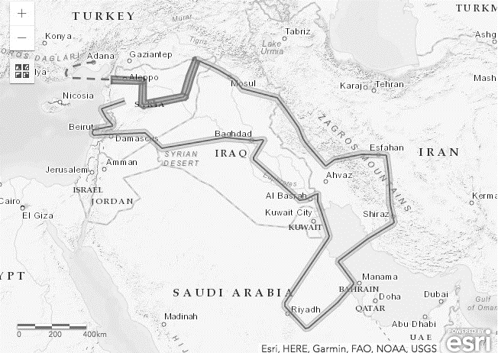
The only operational flights for the British pilots for most of their first year, were over the Middle East. Nineteen were flown in all, including mission B8638 on 10 September 1959 over Syria, Iraq, Iran, Saudi Arabia, and Lebanon.
The route flown by Mission B8638 on 10 September 1959.
David Dowling recalled one of these missions:
‘After about forty minutes you were out of radio contact with base and usually across a border into another country. You were now completely on your own flying an illegal flight. In other words, you were a spy with no legal rights in the event of your capture. It has never ceased to amaze me that we did not lose a plane nor have a forced landing in the nearly two years that we flew with the Incirlik detachment. It was only when Frank Powers was shot down that we had to face up to the inevitable.
I often wondered what was going on down below, as sometimes we over flew our own bases in Cyprus and at Masirah Island in the Gulf. They were probably sitting drinking coffee after a satisfying lunch, or still in the bar, while we were struggling to breathe, and with every nerve taught.’
Detachment B had three T-33s for training, as well as its four U-2s. David Dowling recalled:
‘The T-33 training flights were over Turkey, and initially also Greece until it was declared off limits by London. These flights helped to ensure that the four pilots remained proficient, especially in navigation, for which only basic provision had been made in the U-2. The primary instrument was a drift sight offering different levels of magnification looking down. The optical path could be switched to look up, thus becoming a sextant. Otherwise, there was only a radio compass. That was not much use when flying over desolate areas with few stations.
It was essential to carefully study the maps and make annotations to help identify turning points, maintain the desired tracks, and understand where to turn the main camera on and off. To obtain the best imagery, flight line deviations of no more than a quarter mile were required. In variable crosswinds, it was difficult to fly to such fine limits. The detachment navigators provided the pilots with map charts cut into strips and pasted onto up to ten double-sided boards. In the cramped cockpit, these were not easy to handle.’
But it wasn’t all hard work. David Dowling again:
‘The T-33 flying was great fun as there were virtually no restrictions to our flying over Turkey. The local people were not encouraged to complain of low flying.’
Robinson reported a visit to the Det by Gp Capt Bingham Hall, during which he was flown in one of the T-33s, evidently with some vigour:
‘We trust that any injuries inflicted on his health will not be long-lasting, and will not deter future visits from the Air Ministry!
Some training and ferry flights were not without incident. MacArthur was over the Bay of Biscay, en route to Watton, when his hydraulics failed. That would mean a tricky, no-flap landing. There was a crosswind at Watton, so he diverted to Brize Norton which, being a USAF B-47 base, had a longer runway. His first landing attempt was too fast: 90 knots crossing the threshold instead of 75 knots. He went around, made a flatter approach, and as soon as the wheels hit the runway, he shut off the engine.
Two upgraded U-2C models arrived at Det B in August 1959. The P&W J75 replaced the J57, boosted power by 4,800lb to 16,000lbst and altitude by 4-5,000ft, to a theoretical maximum of over 76,000ft if the cruise-climb was performed at max power. However, this reduced the range. Henceforth, flights were planned to cruise-climb at lower thrust, to restore the range. They were also levelled off at 70,000ft to increase range, since the latest intel was that the new Soviet surface-to-air missile was not effective above 65,000ft. External wing slipper tanks followed in March 1960, adding 200 more gallons.
In late October 1959, the Air Ministry decided that the British pilots could join the Americans in flying along the Soviet southern border, usually at night, to intercept telemetry from the ballistic missile test flights from Tyuratam. A special sensor replaced the big B-camera in the large bay behind the cockpit. These missions, codenamed HOT SHOP, were alerted when SIGINT from ground stations or other aircraft indicated that a missile launch was imminent.
Operation HIGH WIRE
Political permission to mount a Soviet overflight, by either the British or the Americans, proved difficult to obtain. There were months of fruitless planning in London and Washington. Finally, an American mission was authorised and flown in July 1959, codenamed TOUCHDOWN.
Robinson reported with some frustration:
‘Naturally, the OLDSTER personnel were keenly dis-appointed that they were not participating in the operation. A temporary drop in morale was apparent. We had always felt that, in spite of the politicians, this mission would be flown by us. A certain loss of face was inevitable.’
Finally, Prime Minister Harold Macmillan approved a British overflight. It was codenamed Operation HIGH WIRE, and took place on 6 December 1959, flown by Robbie Robinson. As in the 1957 series of overflights, and the recent Operation TOUCHDOWN, the take-off was from Pakistan, to exploit the Soviet early-warning radar gap. Peshawar was the departure point, and the landing was at home base, Incirlik.
In Journal 77, along with a map of the route flown, I explained the intricate planning, fine calculations, and provision of multiple options that was undertaken for these overflights. So I will not repeat them here, except to note that a back-up pilot was always prepared, suited and pre-breathing oxygen, in case the primary pilot became sick at the last moment. For this mission, it was John MacArthur. Mike Bradley flew a simultaneous roundtrip deception flight from Incirlik, designed to confuse Soviet air defence radars.
The targets were the Kuybyshev bomber factories, the Kazan and Saratov/Engels bomber bases, the Kapustin Yar and nearby Vladimirovka missile test ranges, and rail lines that might lead to new and as-yet unknown missile bases. Robinson said:
‘A lot of people think that flying a single-engined aircraft at that height, all the way over Russia, sounds fraught with danger. In fact, we had great faith in the equipment (…) the Pratt & Whitney engine was magnificent. I mean it never hiccupped; it just kept on going.’
But although Robinson described the flight as relatively uneventful, there were a few problems that he described:
‘The initial stage of the flight was over 700 miles of undercast (so) the navigation (…) was virtually pure dead reckoning. The celestial was only of use for checking ground speeds, and there were no radio aids. A 40 mile track error resulted, which was corrected 100 miles prior to point E.’
On flights over denied territories, contrails were a dead giveaway. A small rearwards-facing mirror was mounted just outside the cockpit, so that pilots could monitor them. On this flight, Robinson said:
‘Although they ceased at 55,000ft on the climb, as the flight progressed, I noted that the outside air temperature decreased to below minus 41 degrees, where contrails appear. Finally a light trail with occasional puffs was observed. At that time, I was maintaining 70,000ft per the flight profile, so to try and clear the contrail layer, I started to climb. At 73,000ft the trail persisted only intermittently, so I maintained that altitude until later in the flight, where the temperature started to rise and I returned to 70,000ft.’
But this action, together with strong headwinds, resulted in higher fuel consumption. So Robinson was obliged to take a cut off to the most northerly part of his route, which had been pre-planned as an option. Unfortunately, this meant that he missed one vital target – Kazan.
The progression of the deployment, the mission, and the recovery was, of course, keenly followed in the Air Ministry and Project HQ. As Robinson recalled: ‘During my overflight, CAS Sir Dermot Boyle stayed up all night in the Air Ministry.’ Robinson’s flight took 8 hours 15 minutes. David Dowling described what it was like after a long overflight:
‘You are absolutely exhausted. It catches up with you once you leave the compound. You are far too tired to sleep or sit still. A drink may help; two do not. Even food is difficult to face. It will be about three days before you are re-hydrated and feeling anything like normal.’
Operation KNIFE EDGE
The second British overflight was alerted in early January 1960. It would fly north to cover Kazan, the suspected strategic bomber factory that had been missed on HIGH WIRE, and then go west to survey aircraft factories and missile facilities. Like the previous British overflight, it would take off from Peshawar and land at Adana. But poor weather over the target areas delayed the mission until 5 February. It was codenamed Operation KNIFE EDGE. The pilot was John MacArthur. Mike Bradley was the back-up, and David Dowling flew the deception mission.
The deployment to Pakistan was troubled. The first two attempts to ferry the mission U-2 from Incirlik to Peshawar were aborted by their American pilots due to unserviceabilities after take-off. The second attempt involved Article 360, which had a bad reputation, as MacArthur noted:
‘I flew it on a training mission. I could feel it wasn’t right through my backside. “I’m sure that it’s yawing”, I told one of the most experienced American pilots. He agreed, laughing. That autopilot never flew right.’
In fact, the autopilots remained a cause of concern throughout 1959 and into 1960. As Robinson noted:
‘Hand-flying the U-2C at maximum altitude requires undivided attention, and it cannot be visualized that a pilot would be able to hand-fly the aircraft and also maintain accurate flight line coverage.’
(Incidentally, the autopilot on ‘360’ continued to give trouble, and it failed again on Gary Powers’ ill-fated overflight three months later).
A second substitute jet was hurriedly made ready and ferried to Peshawar. It arrived with not much time to be prepared for the mission take off. As MacArthur recalled, fuel spilled out during refuelling, because the wings were still hot. That caused the fuel counter to be wrongly set. Moreover, because of the delay, all the precomputed star settings were out of date. That would mean more dead-reckoning, and eyeball navigation through the drift sight. As he approached the vital target at Kazan, MacArthur realised he had drifted slightly off course:
Operation KNIFE EDGE – the route flown by John MacArthur.
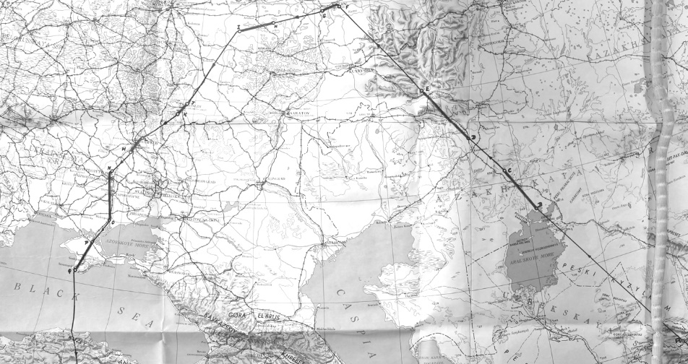
‘The terrain was covered in ice and snow, it was all featureless. Per our training, I made a 50-degree turn to the right and then a 270 to the left so as to line up exactly for the target at Kazan. That turn put me behind schedule by about eight minutes. At the end of the flight, my fuel counter showed 180 gals remaining, when in fact there was only 38 gallons. I had never previously seen the red light come on, but there it was, as I put the gear down for landing.’
MacArthur covered 3,000 miles in a flight lasting 8 hours 40 minutes. His camera captured new Soviet radar and missile sites, missile test and launch facilities, a key military shipyard, arms factories and nearly 100 airfields. The Tu-22 Blinder, a hitherto-unseen jet bomber was photographed at Kazan (see Jnl 77, p111).
Similarly to Robinson’s mission, US ground SIGINT stations reported that Soviet radars had not identified the flight.
There was one more overflight, by an American pilot, in early April 1960. Then came May Day. You can read my books for full coverage of the Powers overflight and shootdown. Dowling said:
‘It was always clear to us that, sooner or later, the Soviet would shoot one of us down and hopefully we would be able to bail out successfully. Our cover story, that we had lost our way, would not convince anyone unless we had been downed close to the border. Also, the cover story could not be sustained with the type of aircraft we flew and the cameras we carried.’
MacArthur recalled:
‘We were in the O-Club at Incirlik when Wg Cdr Kunkler arrived in a hurry from London with the news that Frank had not made it to Bodø. We flew out with Kunkler to London the next morning. I didn’t even have time to pack.’
Robinson said:
‘All four of us pilots were summoned to see George Ward, the Secretary of State for Air. “I may have to lie to Parliament,” Ward told us. He wanted to know what Powers was like, and whether he would divulge the British participation in the project. I told him that Gary Powers was an honest man, and would tell the Russians everything. So, when he faced MPs who obviously suspected something was up, he chose to be evasive.’
In the event, Powers did not reveal anything about the Brits, because he was never asked by his interrogators! Project OLDSTER remained secret for the next three decades, and was not fully declassified until 2020.
Postscript. The MacArthurs emigrated to Australia, and retired in Toowoomba, NSW. So did Andy Cummings, one of the RAF flight surgeons assigned to the U-2 programme at Edwards in the 1960s, as was well described by Ian McBride in Journal 77. One of the great privileges of my being associated with The Dragon Lady for all these years, is my role as a sort of clearing house for information about the programme. It was not until I prepared for a trip to Australia in 2010, that I noticed, from my U-2 correspondence file, that they both lived in Toowoomba – unknown to each other! I was able to arrange a meeting at the small museum at Toowoomba airfield.
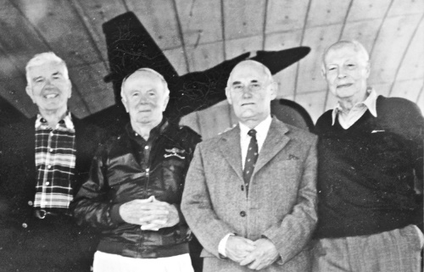
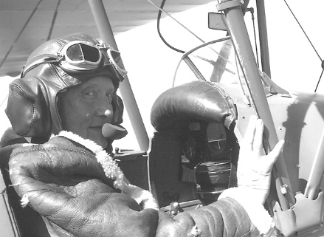
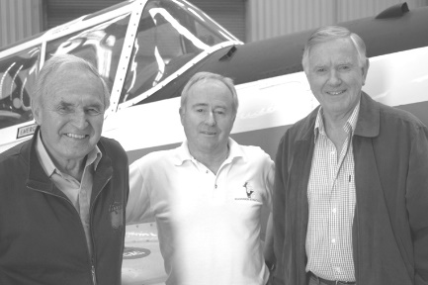
Another veteran who is still alive and kicking in Scotland, where I met him, is Brian Cox, one of the two RAF pilots that completed U-2 flight training in 1959 but were never deployed. Finally, I offer a photo of a small reunion that I was organized at Duxford in 2000. The USAF general was one of the instructor pilots at Laughlin AFB in 1958, who trained the RAF contingent. In the background is, of course, the U-2 that is displayed in the American Air Museum. I was partly responsible for getting it there – but that, as they say, is another story.
Left - 50+ years after his stint on the U-2 Brian Cox was still flying – in a Tiger Moth. Right, L-R, Mike Bradley, Maj Gen Pat Halloran (USAF Retd), David Dowling and Norm Mackie at an informal reunion at Duxford .
Half a century after their involvement in the U-2 programme, two of its veterans, John MacArthur (left) and Andy Cummings, flanking the author, at Toowomba.

Chris Pocock has written several books devoted to the U-2. For a comprehensive account of the early U-2 programme, 50 Years of the U-2 (Schiffer; 2005) is strongly recommended. Ed

